UX Check Results

# Heuristic: Visibility of system status

# Severity: 4

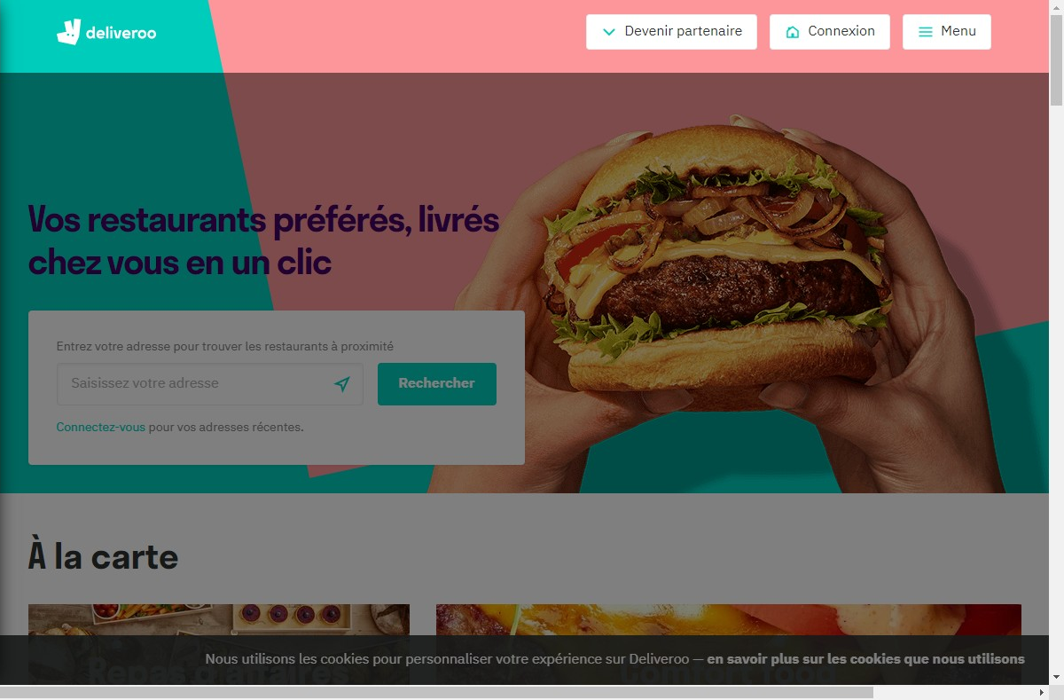

# Notes:

Visible et clair

# Heuristic: Match between system and the real world

# Severity: 4

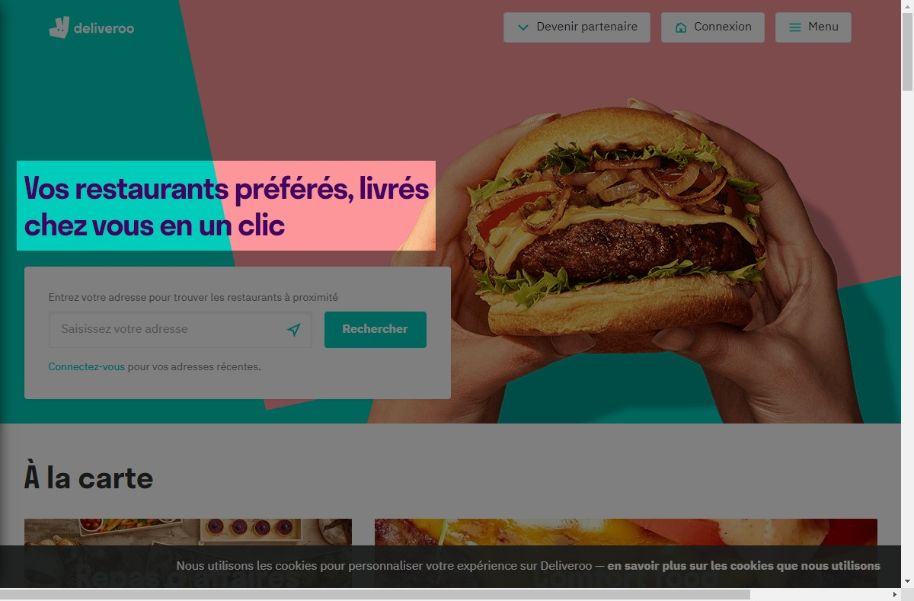

# Notes:

Le site est bien en français

# Heuristic: User control and freedom

# Severity: 4

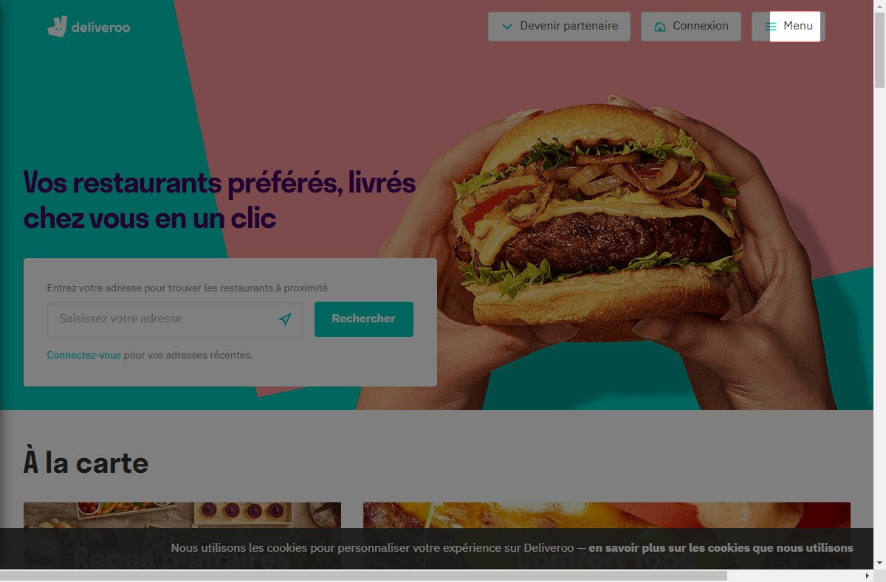

# Notes:

Menu d’accès varié et libre

# Heuristic: Consistency and standards

# Severity: 4

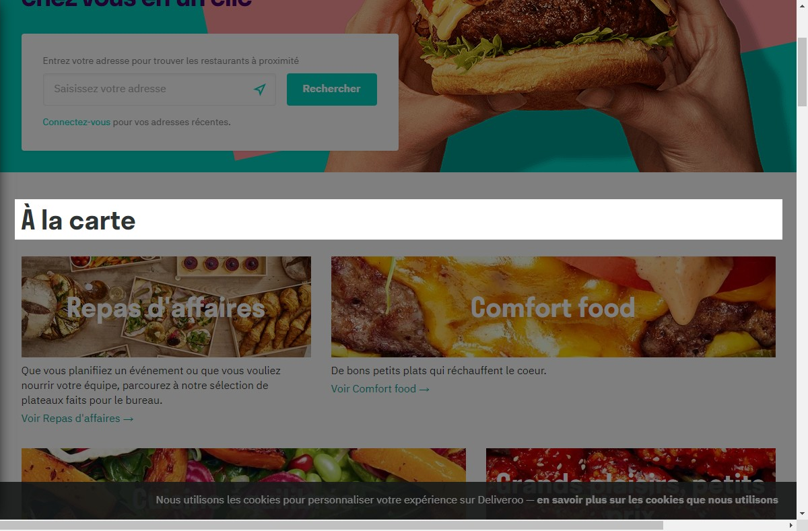

# Notes:

Tres clair et et compréhensible

# Heuristic: Error prevention

# Severity: 4

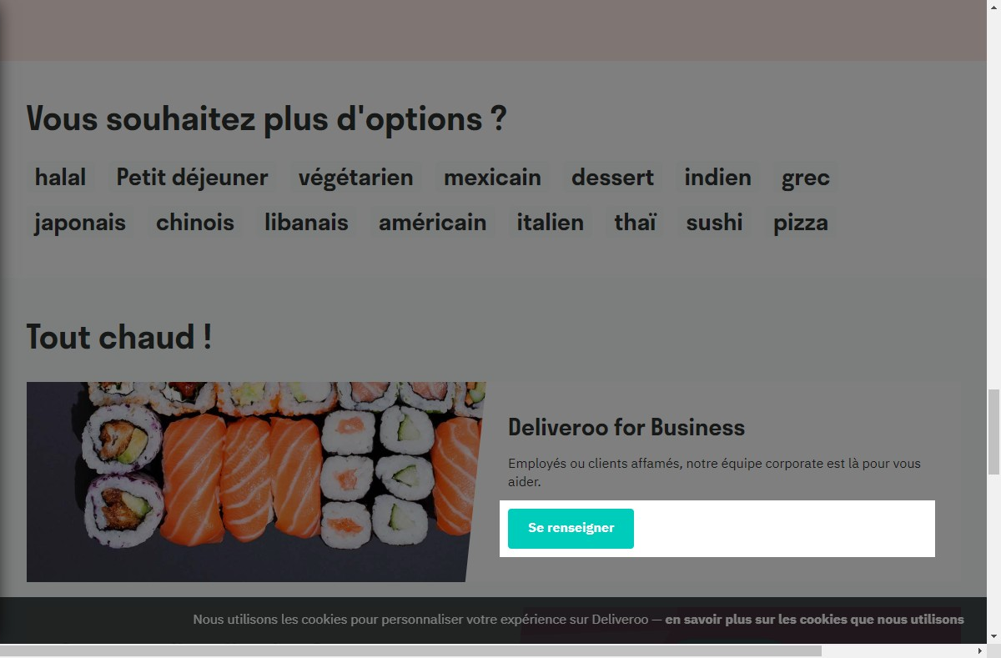

# Notes:

Bouton d'aide clair et précis

# Heuristic: Recognition rather than recall

# Severity: 0

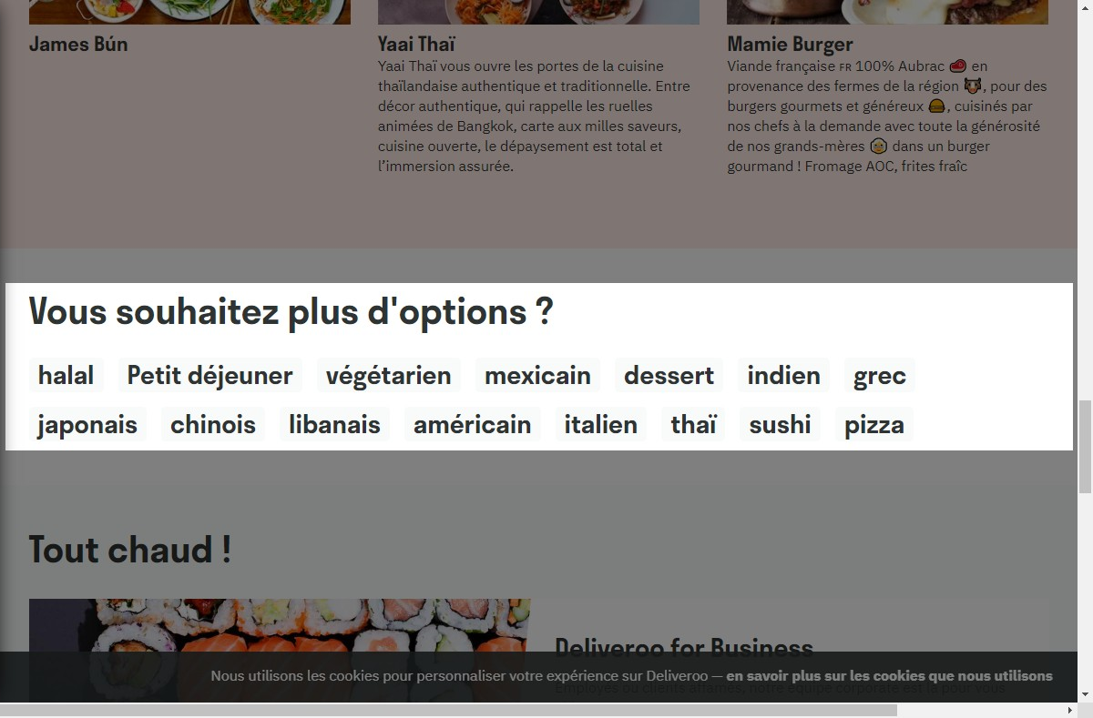

# Notes:

Visible et clair

# Heuristic: Flexibility and efficiency of use

# Severity: 4

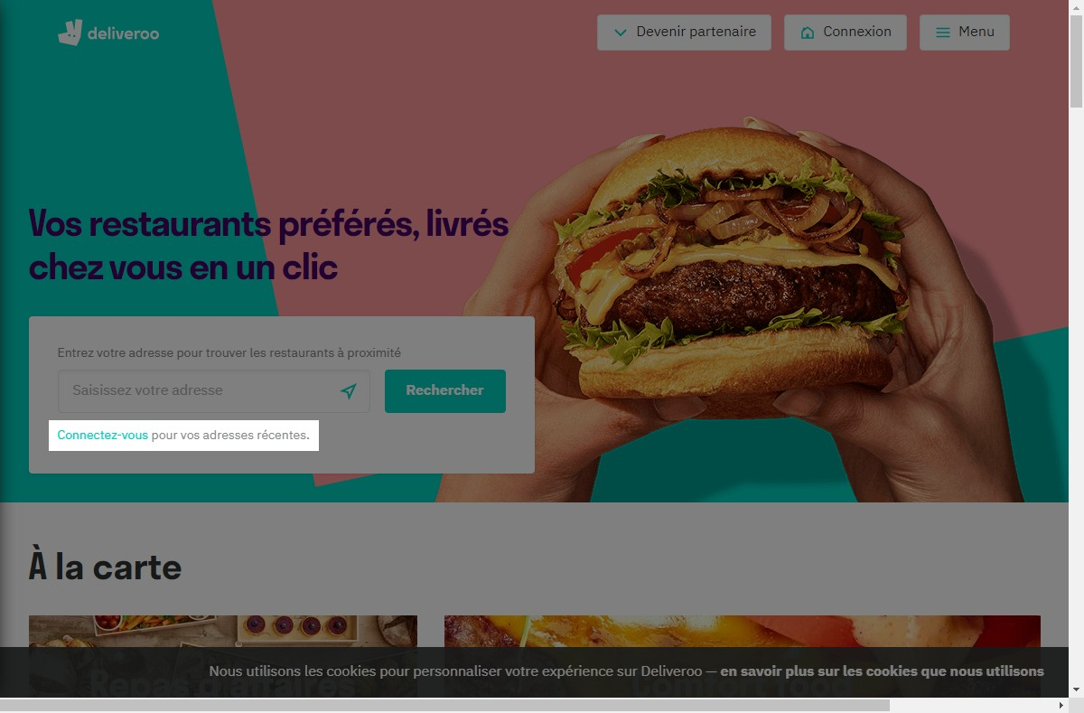

# Notes:

Plutot discret mais explicite

# Heuristic: Aesthetic and minimalist design

# Severity: 4

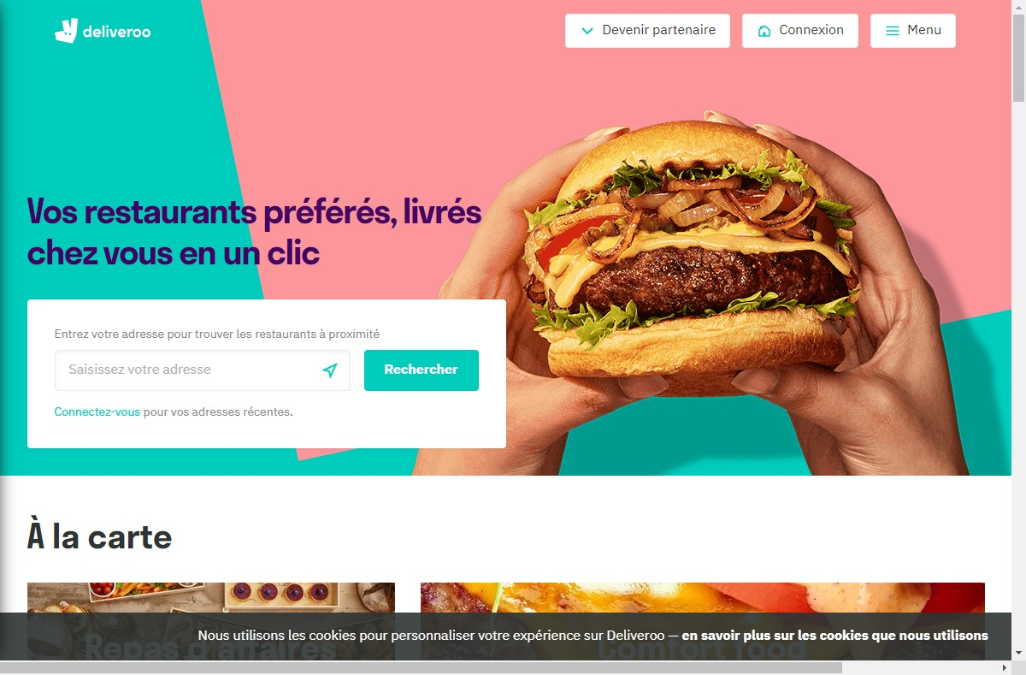

# Recommendation:

Tres bon style et moderne

# Heuristic: Help recognize &amp; recover from errors

# Severity: 4

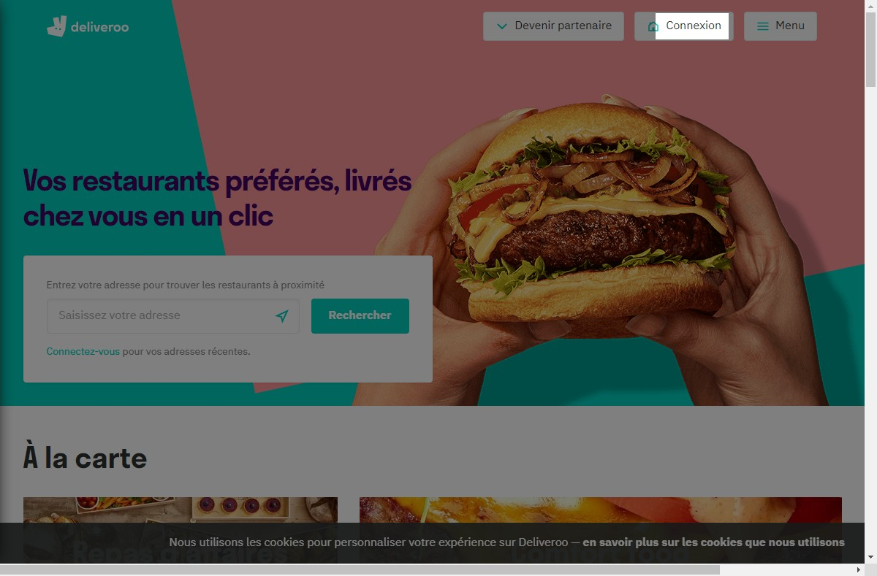

# Notes:

Tout est en français, parfait

# Heuristic: Help and documentation

# Severity: 4

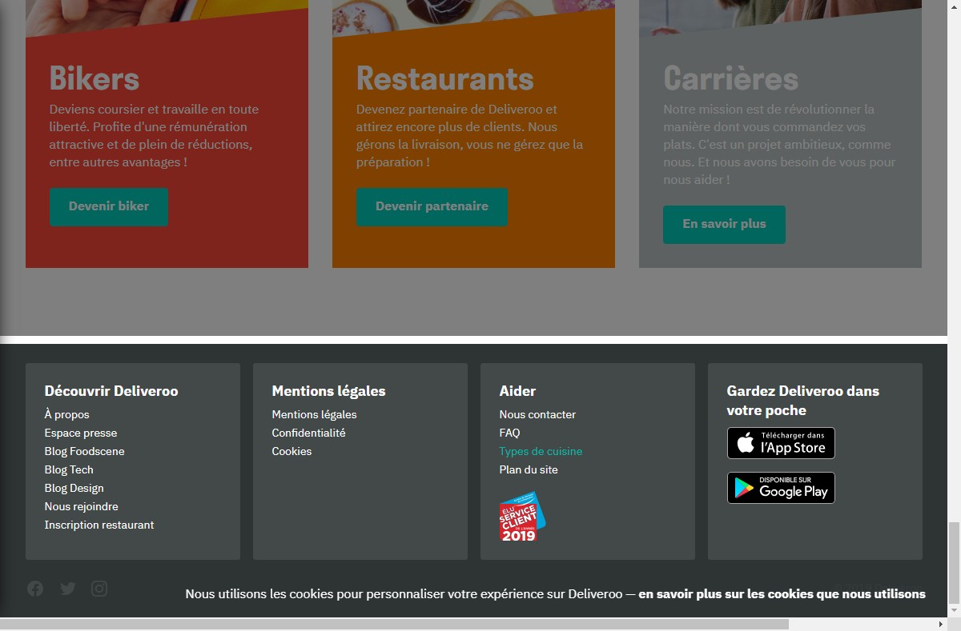

# Notes:

D'option et tres complet